**Program for infinite loop**

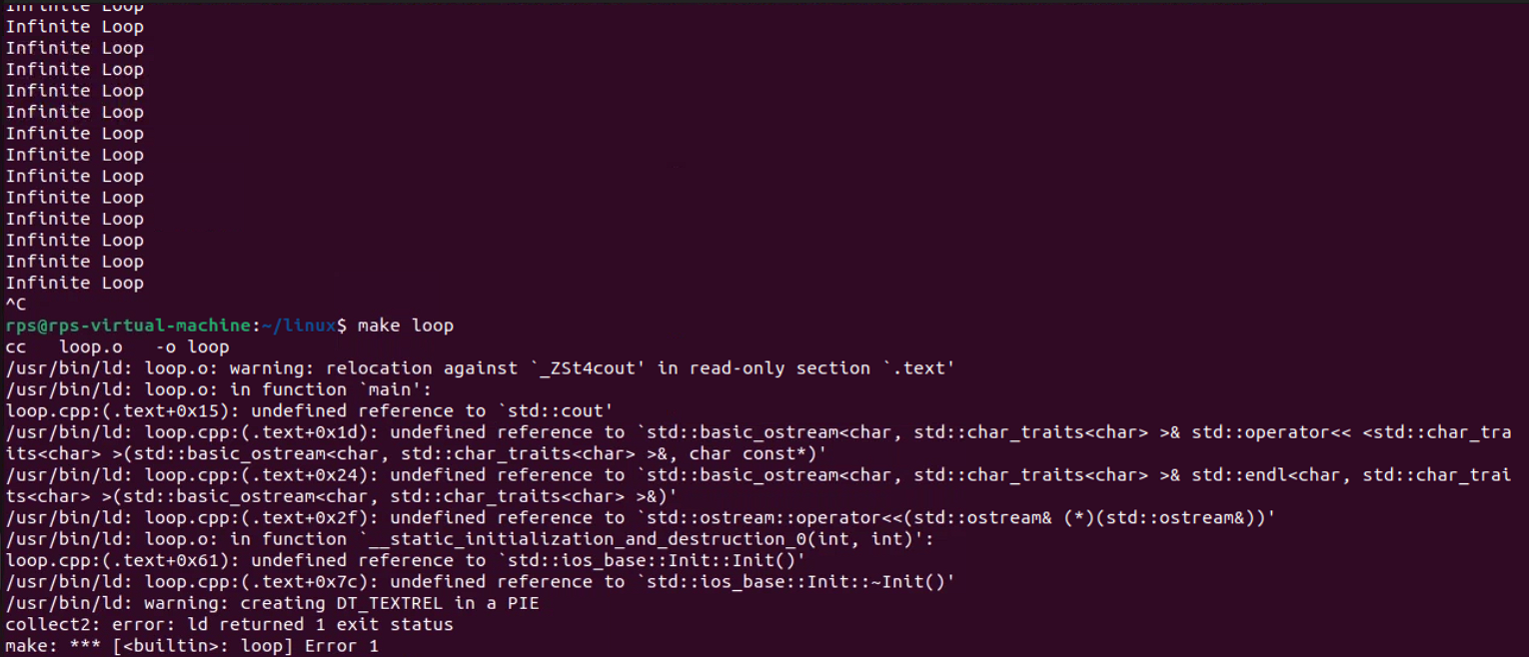

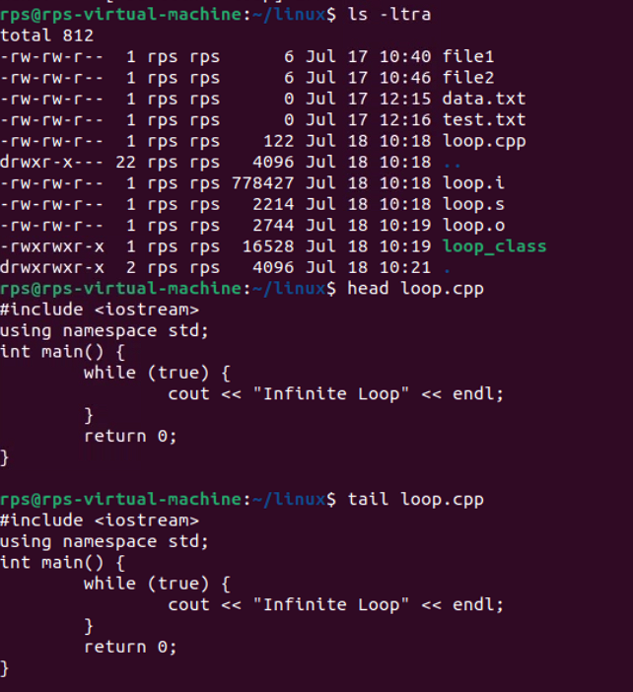

**ps-show process status**

**top-show system usage statistics**

**kill-stop a program.the program is specified by process ID**

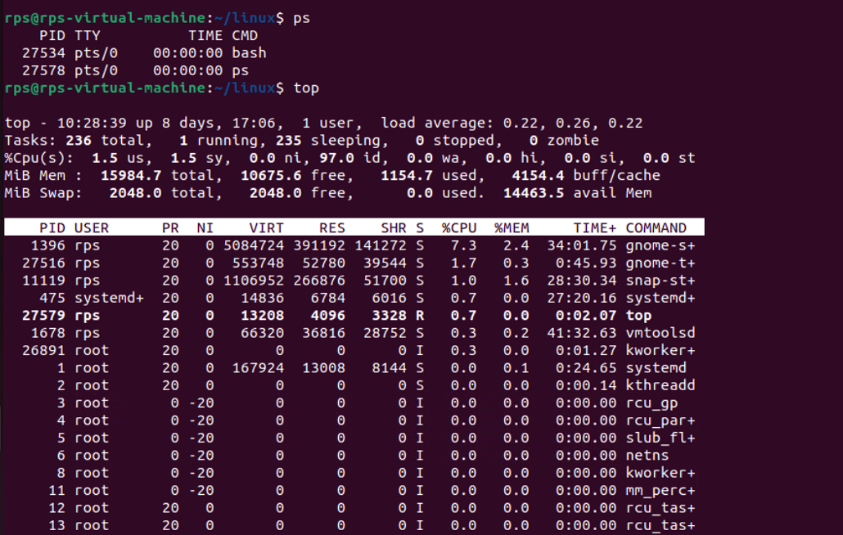

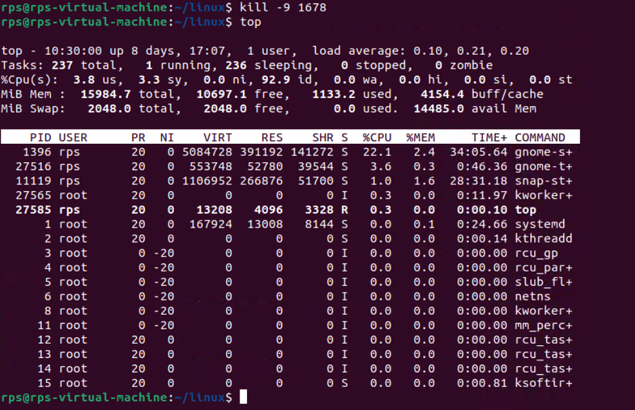

**Program for hello world:**

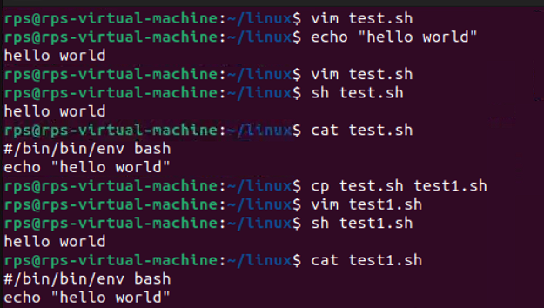

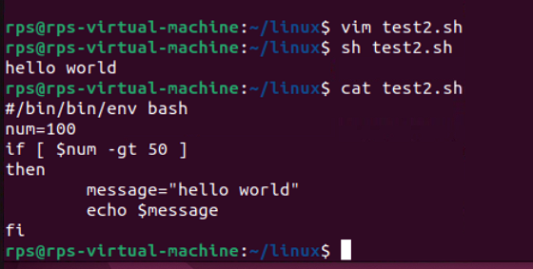

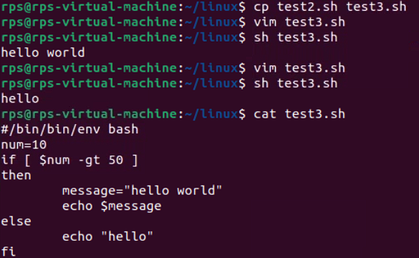

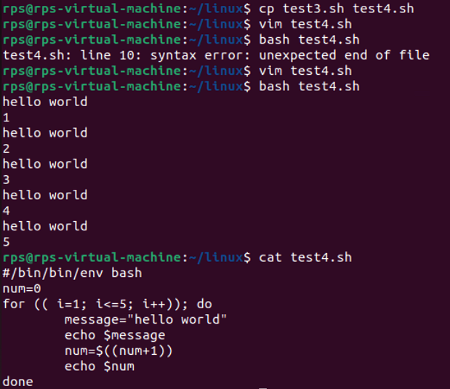

**Program for fruits:**

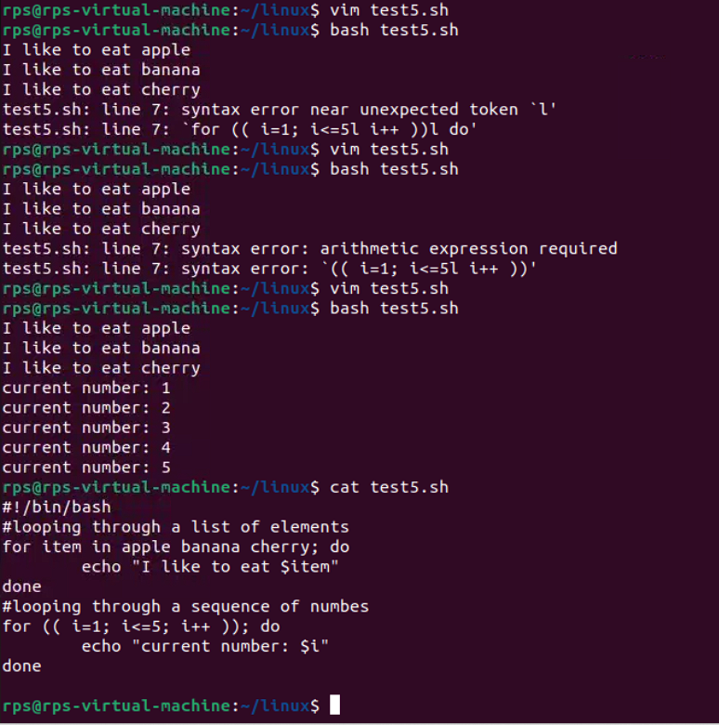

**Bash Scripting: Exercise**

**Exercise 1: Write a shell script called num_loop.sh that loops through every number 1 through 20 and prints each number to standard output. The script should also conditionally print I'm big! for every number larger than 10.**

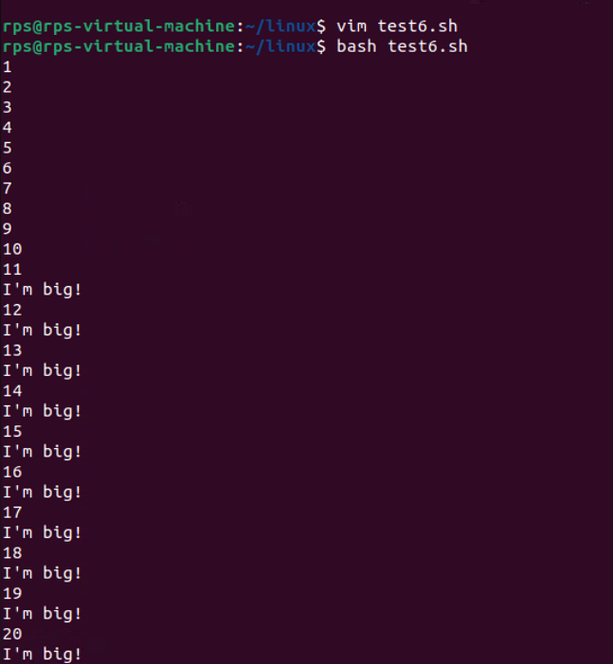

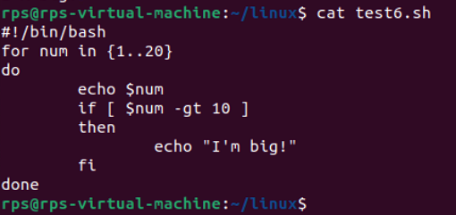

**Exercise-2:**

**Write a shell script called my_folder.sh that takes in two arguments: your name (e.g. ayelet.txt). The script should call a function that creates a folder by the name of the first arguments (e.g. ayelet) and then create a file inside by the name of the second argument (e.g. ayelet.txt)**

**For my name, my function would create a folder named ayelet and a file named ayelet.txt inside of ayelet.**

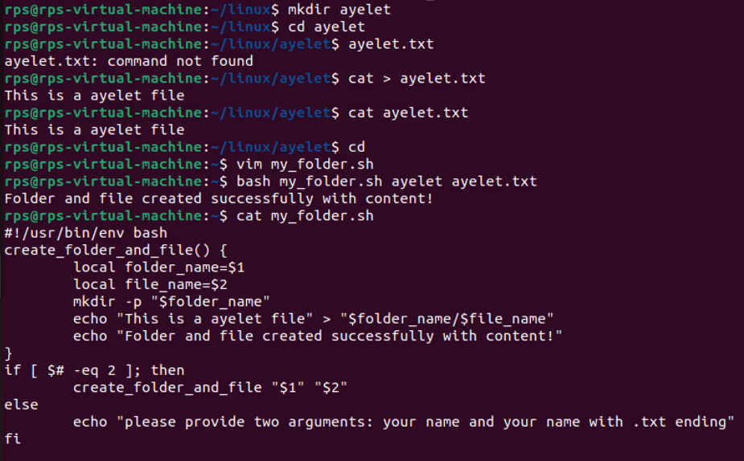

**File Search:**

**Write a command to find all files with the extension .txt in the /home directory and its subdirectories.**

find /home -type f -name "*.txt"

• find: The command used to search for files and directories.

• /home: The directory where the search begins.

• -type f: This option tells find to look for files only (not directories).

• -name "*.txt": This option specifies the pattern to match for file names, in this case, files ending with .txt.

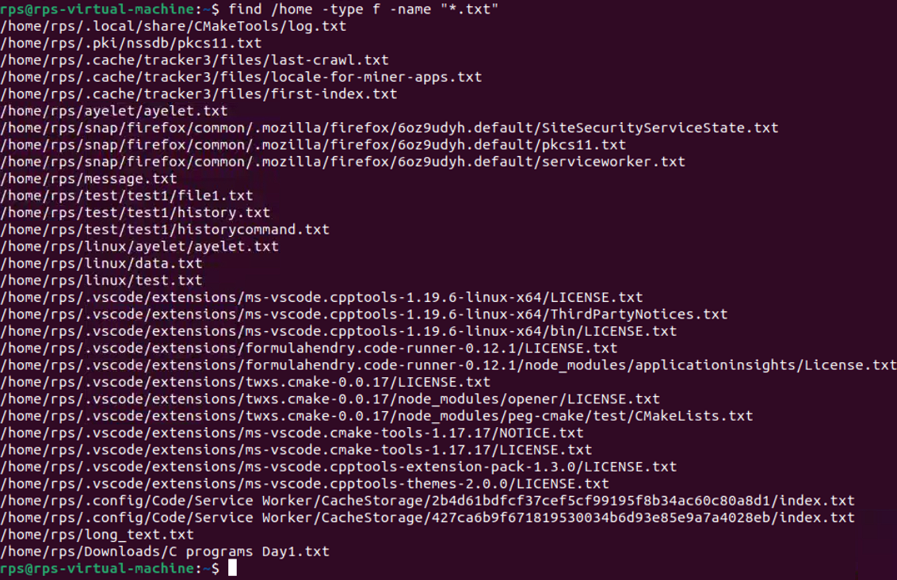

**File Permissions:**

**Write a command to change the permissions of all files in the /var/log directory to 644.**

find /var/log -type f -exec chmod 644 {} \;

• find: The command used to search for files and directories.

• /var/log: The directory where the search begins.

• -type f: This option tells find to look for files only (not directories).

• -exec: This option allows you to execute a command on each file found by find.

• chmod 644 {}: The command to change the file permissions to 644, where {} is a placeholder for each file found.

• \;: This indicates the end of the -exec command.

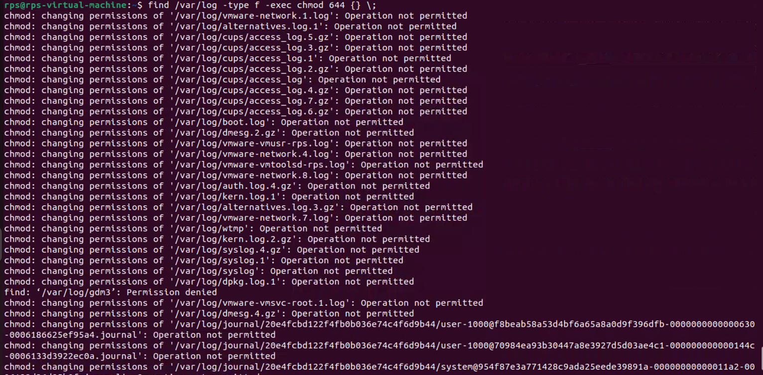

**Disk Usage:**

**Write a command to display the disk usage of all directories in the /home directory in a human-readable format.**

* du (disk usage) reports the amount of disk space used by files and directories.
* -h makes the output human-readable (e.g., in KB, MB).
* --max-depth=1 limits the depth of the directory tree to be reported.
* /home specifies the directory to check.

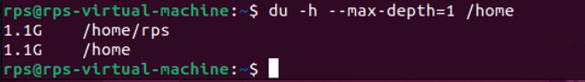

**Process Management:**

**Write a command to list all running processes that contain the name "apache" in their command line.**

ps -ef | grep apache

• ps stands for "process status".

• e stands for "all" and shows all running processes.

• f stands for "full" and shows the full command line.

• grep apache searches for the pattern "apache" in the output of the ps command.



**Text Processing:**

**Write a command to count the number of lines in a file named error.log.**

**Command:** wc -l message.txt

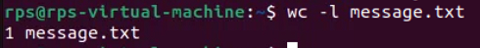

**Network Configuration:**

**Write a command to display the IP address of all network interfaces on the system.**

**Command:** ip -o -4 addr show | awk '{print $2, $4}'

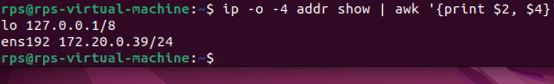

**Package Management:**

**Write a command to install a package named htop using the package manager.**

**Command:** sudo apt-get install htop

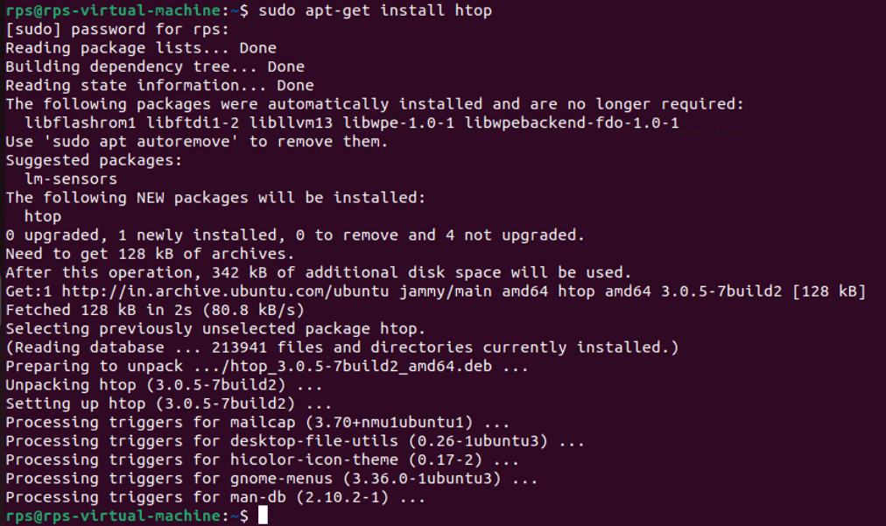

**User Management:**

**Write a command to add a new user named developer to the system.**

**Command:** sudo adduser developer

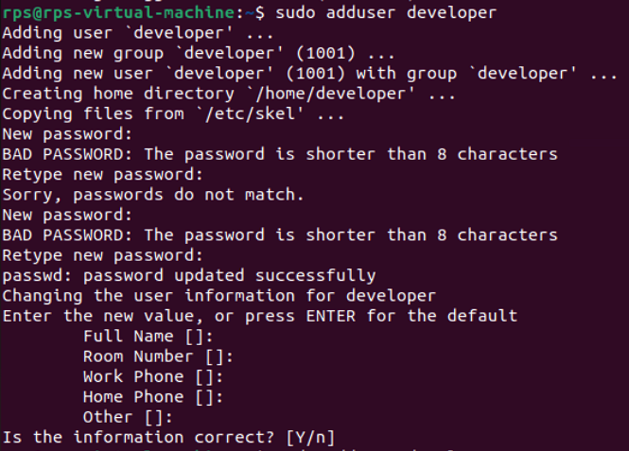

**File Compression:**

**Write a command to compress a directory named backup into a .tar.gz file.**

**Command:** tar -czvf backup.tar.gz backup

* tar is a command to create or extract tar archives.
* -c creates a new archive.
* -z compresses the archive with gzip.
* -v shows verbose output.
* -f backup.tar.gz specifies the name of the archive file.
* backup is the directory to be compressed.

**System Monitoring:**

**Write a command to display real-time system resource usage, including CPU, memory, and disk I/O.**

**Command:** htop



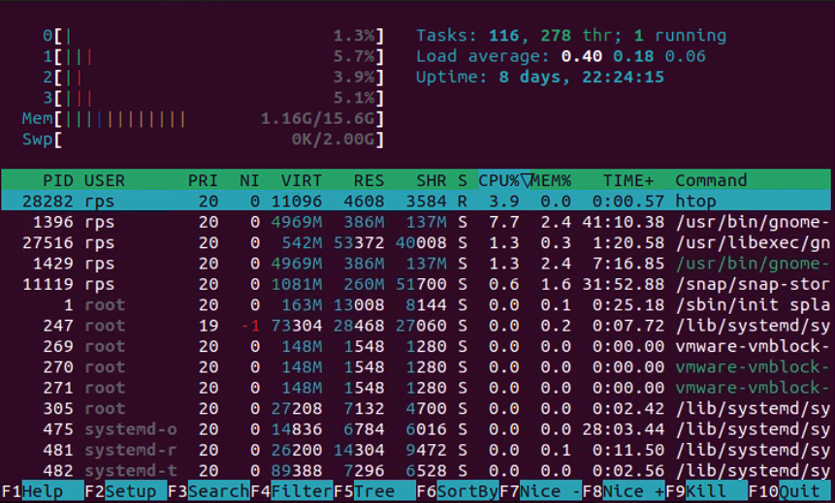

**Shell Scripts**

**Backup Script:**

**Write a shell script to back up a directory named /data to /backup with the current date appended to the backup file name.**

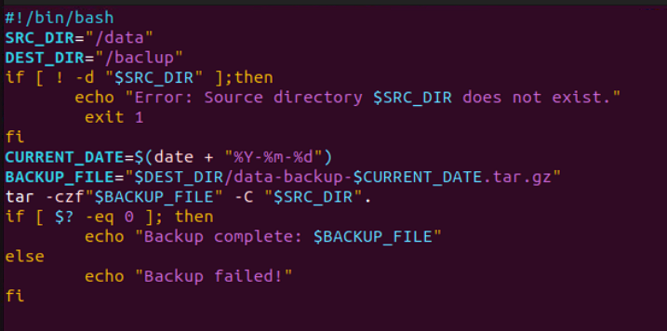



**Log Rotation:**

**Write a shell script to rotate log files in the /var/log directory, keeping only the last 7 days of logs.**

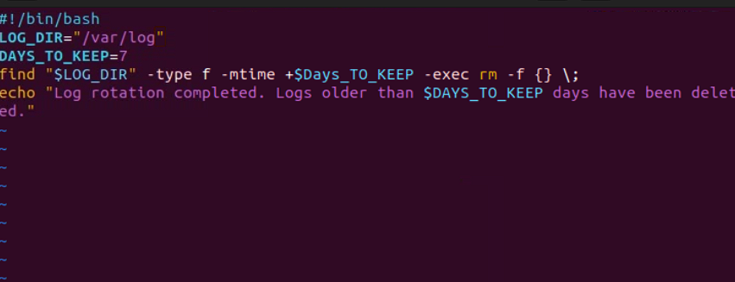

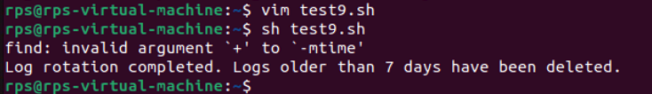

**User Report:**

**Write a shell script to generate a report of all users currently logged into the system and save it to a file named user_report.txt.**

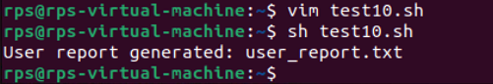

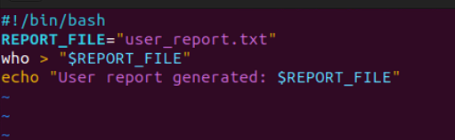

**Disk Space Alert:**

**Write a shell script to check the disk usage of the /home directory and send an email alert if the usage exceeds 80%.**

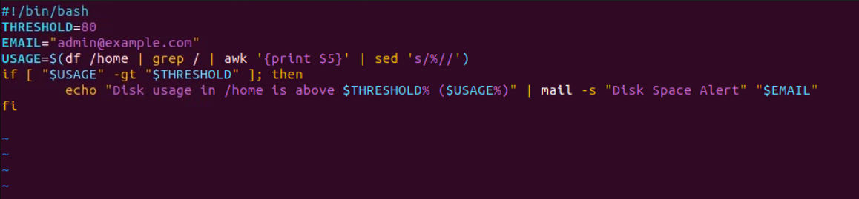



**Service Monitor:**

**Write a shell script to check if the nginx service is running and restart it if it is not.**

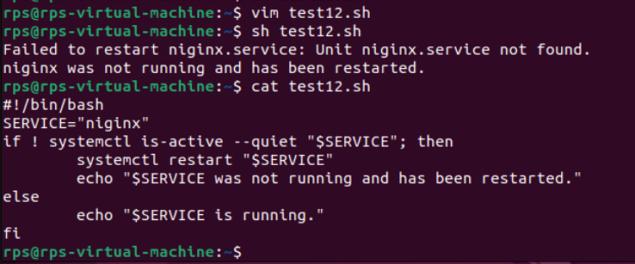

**File Cleanup:**

**Write a shell script to delete all files older than 30 days in the /tmp directory.**

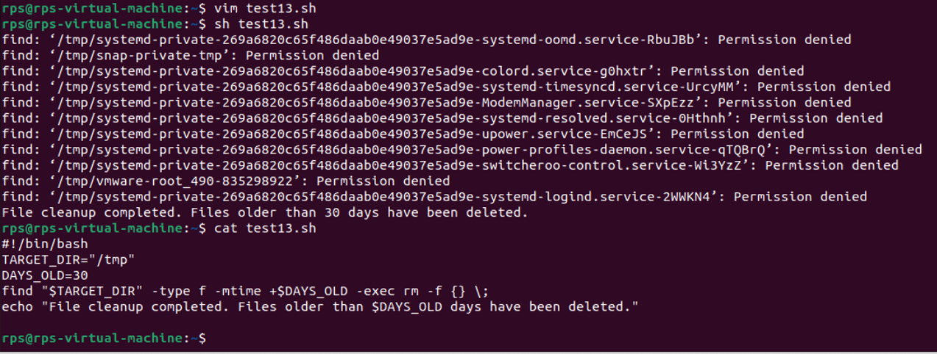

**Automated Updates:**

**Write a shell script to automatically update all installed packages on the system.**

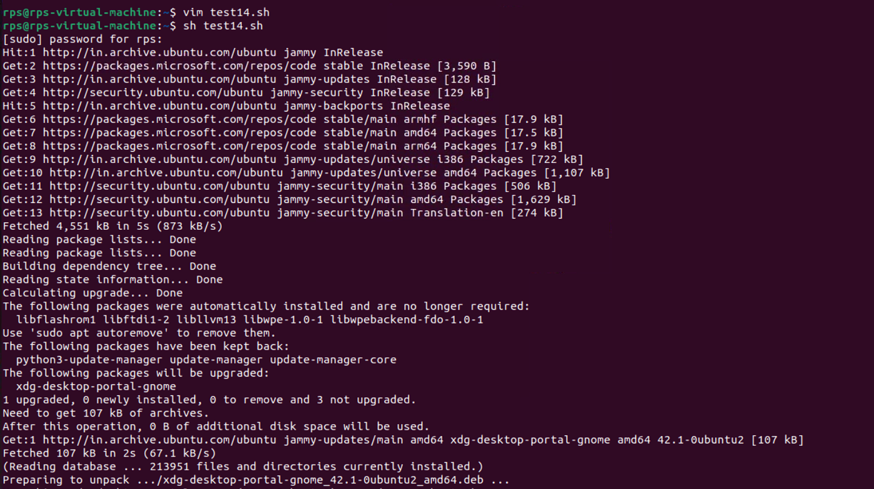

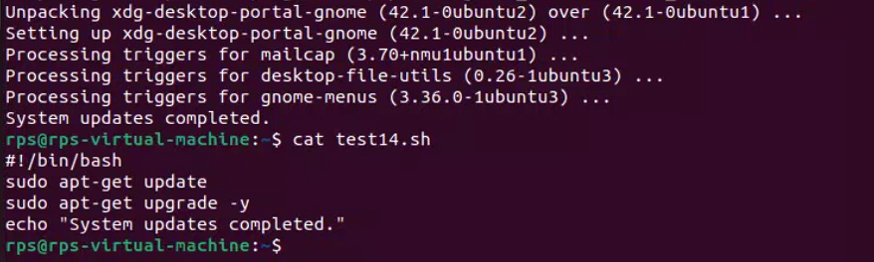

**Database Backup:**

**Write a shell script to back up a MySQL database named sales to a file named sales_backup.sql.**

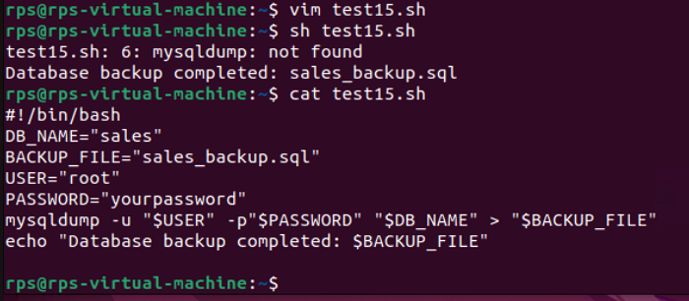

**System Information:**

**Write a shell script to display system information, including hostname, OS version, and kernel version.**

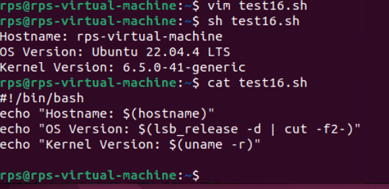

**Cron Job:**

**Write a shell script to schedule a cron job that runs a specific command every day at midnight.**

